
21052 Oxnard Street
Woodland Hills, CA 91367
T (818)999-2232
F (818)999-2269
myedigaryan@stonedeanlaw.com

Meline Yedigaryan
Associate Attorney

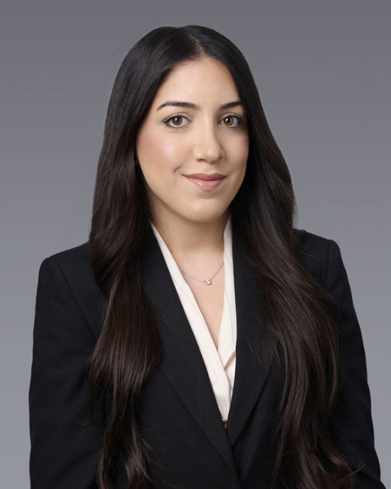

Meline Yedigaryan is an Associate Attorney at Stone I Dean. Her practice focuses on civil litigation and personal injury. Meline was admitted into the California State Bar in 2024. Prior to joining Stone I Dean, Meline gained personal injury experience at various law firms throughout Los Angeles, providing support to the firms’ litigation teams and assisting with trial preparation for various personal injury matters on the plaintiff’s side, including motor vehicle accidents, products liability, premises liability, slip and falls, and dog bites.
Meline received her law degree from Southwestern Law School in Downtown Los Angeles in 2023. During her time at Southwestern, she was the president of the Armenian Law Students Association and served as a Dean’s Fellow. In her free time, Meline enjoys spending time with family and friends, working out, running, and traveling.
Areas of Practice:
- General Civil Litigation
- Insurance Defense and Litigation
- Personal Injury
- Premises Liability
Education:
- Bachelor of Arts, Political Science, California State University Northridge
- Juris Doctorate, Southwestern Law School
Membership and Activities:
- State Bar of California (2024)
- Armenian Bar Association
- Consumer Attorneys Association of Los Angeles
- Consumer Attorneys of California
- California Lawyers Association

