
21052 Oxnard Street
Woodland Hills, CA 91367
T (818)999-2232
F (818)999-2269
msherman@stonedeanlaw.com

Maurina Sherman
Associate Attorney

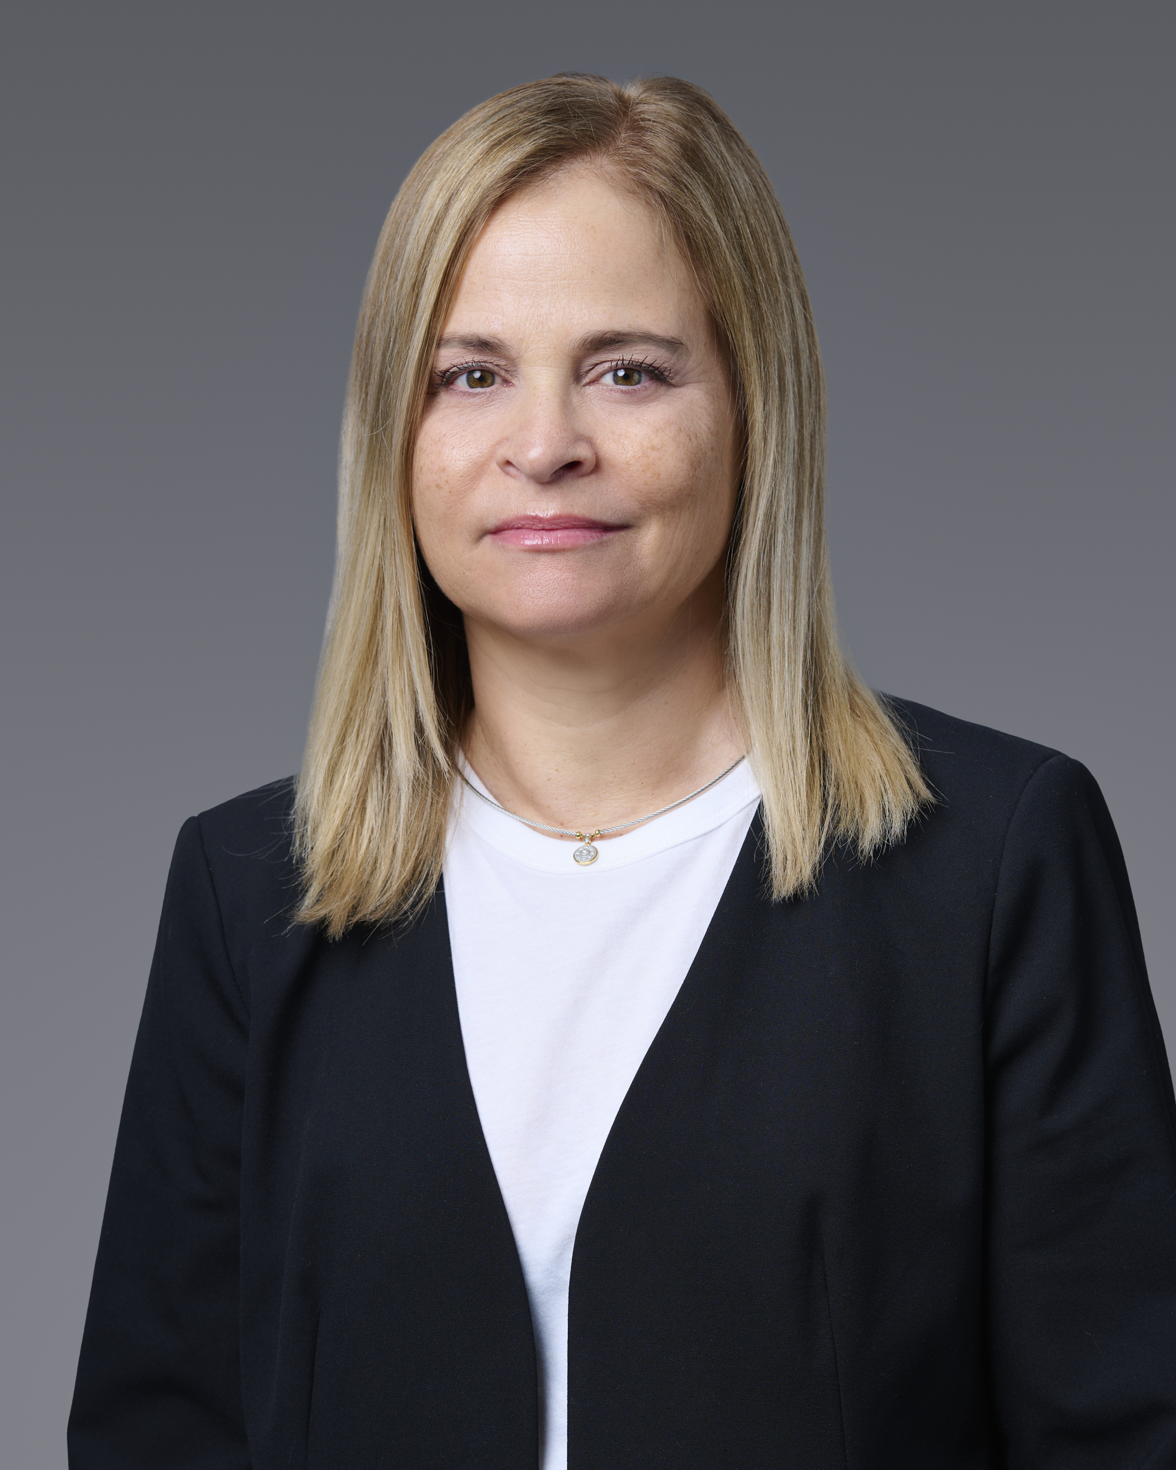

Maurina Sherman is an Associate Attorney at Stone I Dean. Her practice has focused on insurance defense and general civil litigation. Prior to becoming an attorney, Maurina was an entertainment journalist (Los Angeles Time, San Diego Tribune) and a science writer at Lawrence Livermore National Laboratory where she supported the Lab’s mission of ensuring the safety and reliability of the U.S. nuclear weapons stockpile.
As a law student, Maurina earned numerous Witkin Awards for academic excellence, including Legal Writing and Appellate Advocacy, and graduated first in her class. She had the honor of working as a judicial extern to the Honorable Steven Z. Perren in the 2nd District California Court of Appeal, Division Six. In addition to civil litigation, Maurina’s legal interests include constitutional law and environmental justice.
During her free time, Maurina enjoys raising her two daughters and supporting their athletic and performing arts pursuits. She also spends an inordinate amount of time swiffering up after their Golden Retriever “Nick IX,” a Canine Companions service-dog dropout.
Areas of Practice:
- General Civil Litigation
- Insurance Defense and Litigation
- Insurance Coverage
- Personal Injury
- Premises Liability
Education:
- Bachelor of Arts, University of California, Santa Barbara
- Master of Fine Arts, San Diego State University
- Juris Doctorate, Ventura College of Law

