
21052 Oxnard Street
Woodland Hills, CA 91367
T (818)999-2232
F (818)999-2269
ycinnater@stonedeanlaw.com

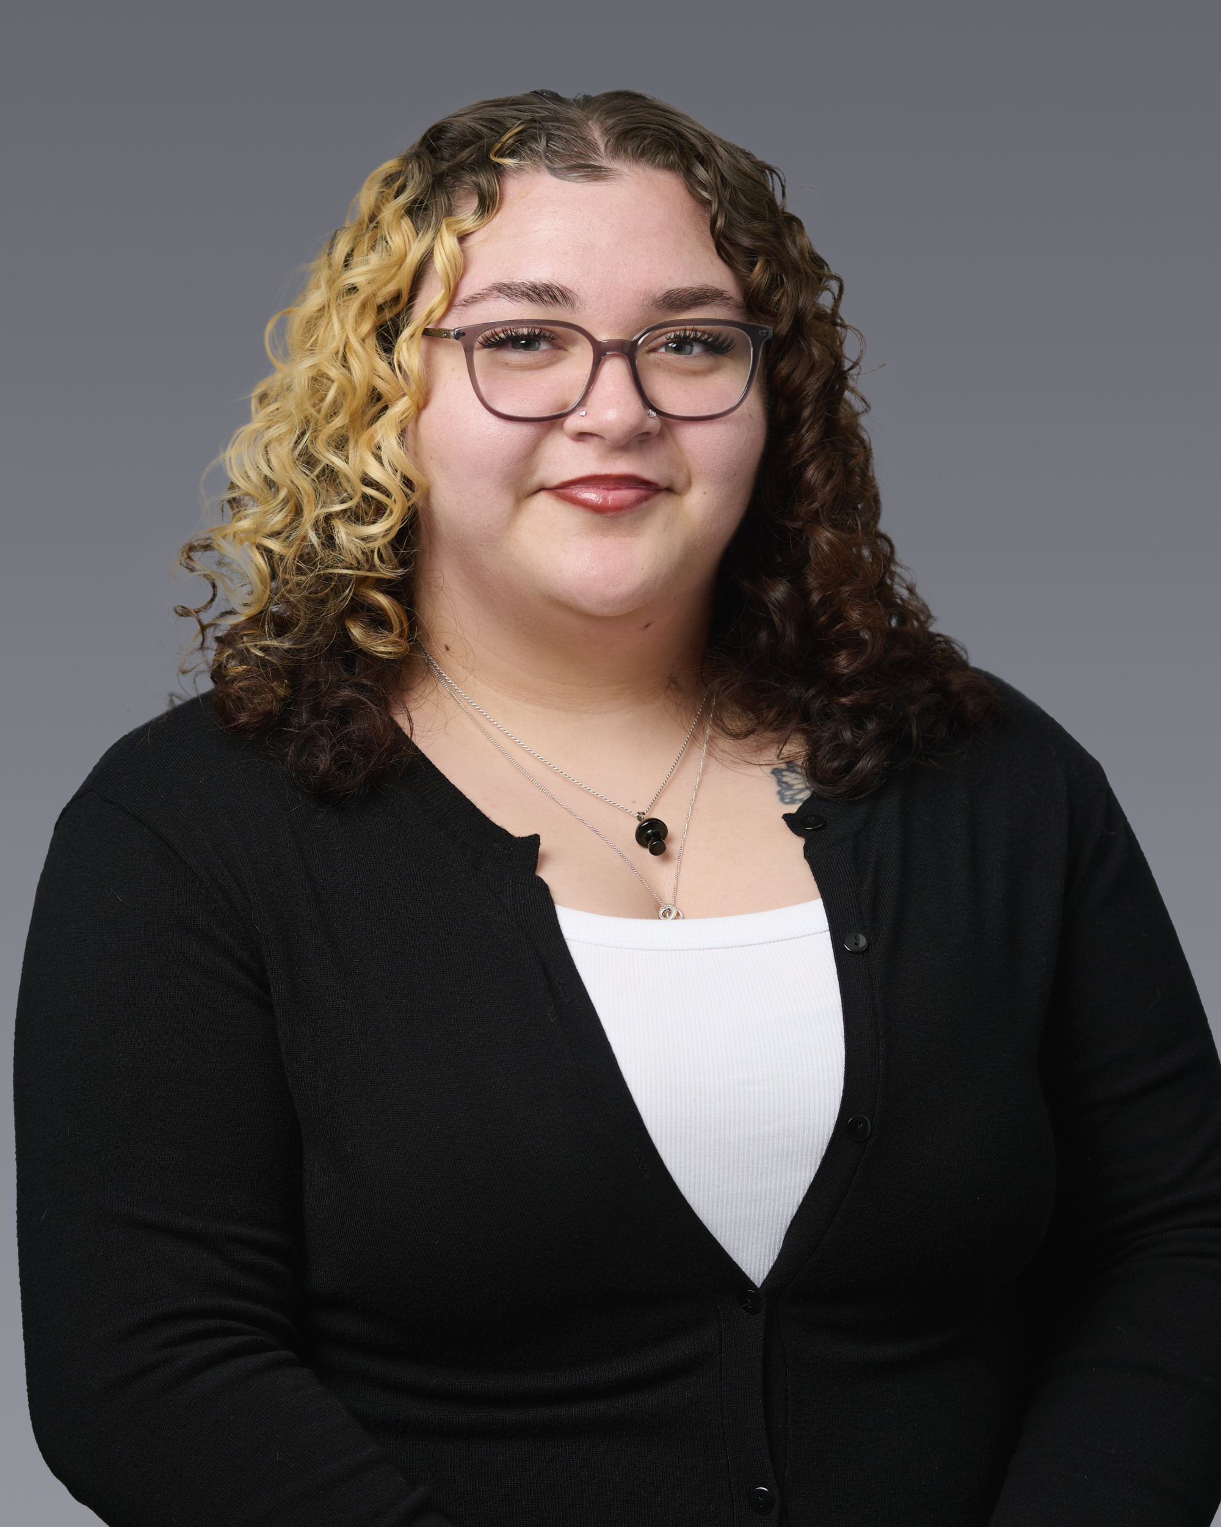
Yvette Cinnater
Front Office Coordinator

Yvette Cinnater, Front Office Coordinator, has a strong background in customer service and a passion for organizing and communication. She supports the team by managing calls, scheduling, and helps keep the office running smoothly. Yvette’s strengths include her eagerness to learn, her ability to make everyone feel welcome, and her consistent readiness to take on any task.
In her free time, Yvette enjoys spending time with friends and family, cooking, and listening to music.

