
21052 Oxnard Street
Woodland Hills, CA 91367
T (818)999-2232
F (818)999-2269
alexa@stonedeanlaw.com

Alexa Rivera
Case Assistant

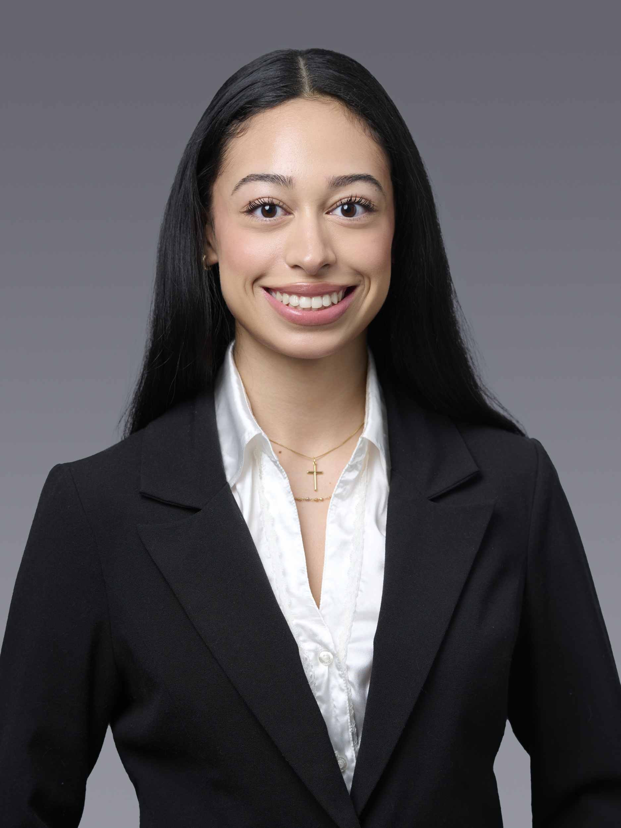

Alexa Rivera, Case Assistant, is focused on maintaining and organizing legal case files, both physical and digital. Her role also includes assisting with case preparation and supporting day-to-day operations. Throughout her role, Alexa is committed to learning the inner workings of legal practice through observations and hands-on experience.
Outside of work, Alexa enjoys going to museums, practicing yoga, taking pottery classes, and spending time with friends.

