
21052 Oxnard Street
Woodland Hills, CA 91367
T (818)999-2232
F (818)999-2269
cramirez@stonedeanlaw.com

Carol Ramirez
Legal Assistant

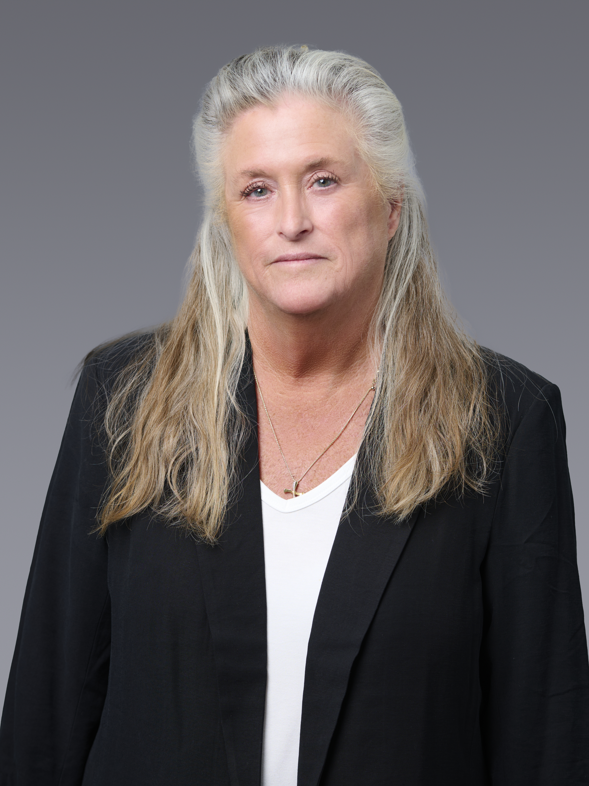

Carol Cataldo-Ramirez, legal assistant, has over 35 years of civil litigation experience, after graduating from the UCLA Extension Attorney Training Program.
Throughout her paralegal career, Carol has worked in various areas of Civil Litigation within the Federal and State Court systems including personal injury, insurance defense, landlord/tenant, wills and trusts, probate and probate litigation, and family law. She also has experience in federal criminal defense as well as federal appellate matters.
While not at work, Carol enjoys watching soccer, spending time with her husband and two grown daughters, and playing with her dogs.

