
21052 Oxnard Street
Woodland Hills, CA 91367
T (818)999-2232
F (818)999-2269
dhariri@stonedeanlaw.com

Daniel Hariri
Law Clerk

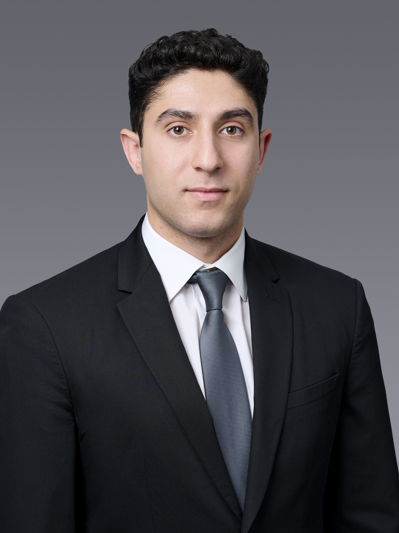

Daniel Hariri, law clerk, is in his second year of law school at Pepperdine University. He also holds a bachelor’s degree in political science from UCLA. Prior to working at Stone Dean, Daniel worked at a plaintiff-side employment law firm and interned at the Los Angeles District Attorney’s Office. As a law clerk, Daniel conducts research, drafts and uploads documents for the firm, and evaluates cases with the attorneys at the firm.
Outside of work, Daniel enjoys exercising, traveling, and spending time with family and friends.

