
21052 Oxnard Street
Woodland Hills, CA 91367
T (818)999-2232
F (818)999-2269
dmurray@stonedeanlaw.com

Debbie Murray
Legal Assistant

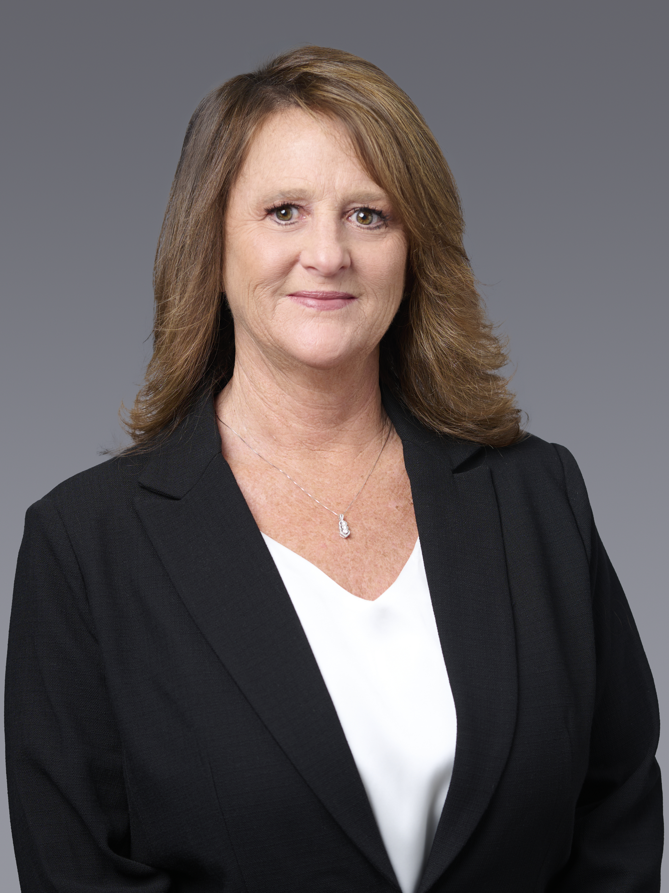

Debbie Murray, legal assistant, has over 30 years of experience working in insurance defense, personal injury, real estate and family law.
She grew up in Santa Clarita where she is currently resides with her husband. Outside of work she loves to travel, spend time at the beach and motorcycle riding. Most of all she values spending time with her children.

