
21052 Oxnard Street
Woodland Hills, CA 91367
T (818)999-2232
F (818)999-2269
kmacksoud@stonedeanlaw.com

Kori Macksoud
Partner

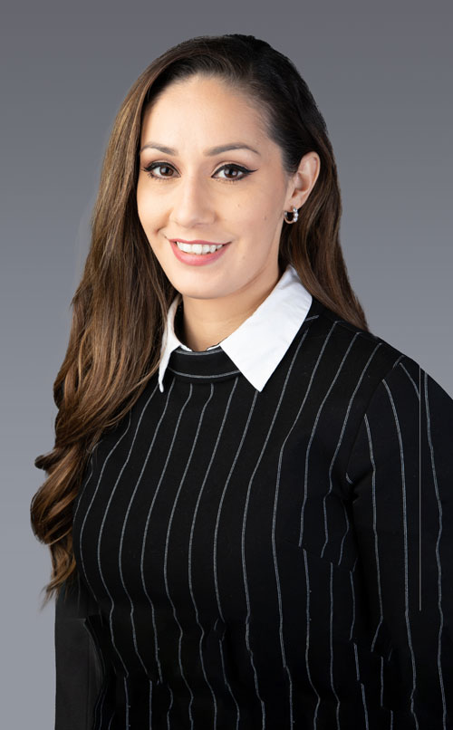

Kori N. Macksoud, Partner, is a seasoned civil litigator representing corporate clients in complex personal injury, premises liability, and general liability matters. With nearly a decade of litigation experience, she partners closely with clients to deliver strategic, business-minded advocacy focused on risk mitigation and efficient resolution.
Her practice encompasses all phases of litigation, from early case evaluation through motion practice, courtroom proceedings, and post-judgment matters. She prepares each case with the expectation that it may ultimately be tried before a jury, ensuring that strategy, discovery, and advocacy are aligned from the outset. Known for disciplined preparation and sharp legal analysis, Kori positions matters for trial when necessary and resolution when appropriate, with settlement posture driven by strength rather than pressure.
She is particularly drawn to cases involving unusual fact patterns or nuanced legal issues requiring careful analysis and creative strategic thinking. Clients rely on her to manage complex, high-exposure files, develop defensible litigation strategies, and protect long-term business interests. She also handles appellate strategy and briefing in defense of favorable rulings, reinforcing her depth of analysis at every stage of a case.
A cum laude graduate and multiple Bernard E. Witkin Award recipient for academic excellence in Constitutional Law, Real Property, Pre-Trial Litigation, and Professional Responsibility, Kori brings analytical precision and practical judgment to her practice.
She is admitted to practice in California and is an active member of the Los Angeles County and San Fernando Valley Bar Associations.
Areas of Practice:
- General Civil Litigation
- Insurance Defense and Litigation
- Personal Injury
- Premises Liability
Articles and Blog Posts:
- CALI[FAIR]NIA
- Quarterly Case Law White Paper
- Court Debates Employee Status of Uber & Lyft Drivers
- The Vacant Chair: How Justice Scalia’s Life and Death Impact American Law
- What Employers Need to Know about Ban the Box
Membership and Activities:
- Los Angeles County Bar Association (LACBA)
- San Fernando Valley Bar Association (SFVBA)
- State Bar of California (2017)
Personal:
Outside of the office, Kori enjoys a full and lively home life with her husband and their three young children. Navigating toddlerhood has sharpened her negotiation skills, tested her patience under pressure, and given her new appreciation for conflict resolution. The joyful chaos of parenting keeps her grounded, and her family remains her greatest source of inspiration and perspective.

