
21052 Oxnard Street
Woodland Hills, CA 91367
T (818)999-2232
F (818)999-2269
tgalstyan@stonedeanlaw.com

Talitha Galstyan
Partner

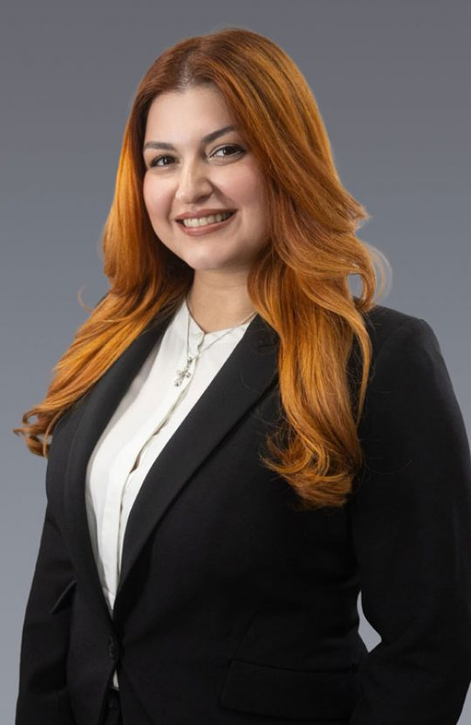

Talitha Galstyan, Partner, is a civil litigation attorney who represents clients in personal injury, premises liability, and insurance-related matters. Her practice focuses on defending high-exposure claims and managing cases through all stages of litigation, from early case evaluation and strategic discovery through trial preparation and resolution. Talitha regularly handles complex litigation matters in California state courts and works closely with clients to develop practical, results-oriented defense strategies tailored to each case.
Prior to joining Stone | Dean LLP, Talitha practiced at plaintiff-side litigation firms where she handled personal injury and insurance bad faith matters. This experience provides her with valuable insight into plaintiff litigation strategy and allows her to anticipate opposing positions while developing proactive defense approaches for her clients.
Talitha earned her Juris Doctor from Loyola Law School, Los Angeles, where she served as Managing Editor of the Loyola of Los Angeles International and Comparative Law Review and was an inaugural member of the Business Law Fellows program. During law school, she externed for the Honorable Ronald S.W. Lew of the United States District Court for the Central District of California.
Talitha remains active in the legal community and volunteers with her local Armenian church.
Areas of Practice:
- General Civil Litigation
- Insurance Defense
- Personal Injury Defense
- Premises Liability
Education:
- Bachelor of Arts, English, University of California, Los Angeles
- Juris Doctor, Loyola Law School, Los Angeles
Membership and Activities:
- State Bar of California
- Association of Southern California Defense Counsel
- Armenian Bar Association
Personal:
Born and raised in Los Angeles County, Talitha enjoys traveling, reading, baking, and working with pottery in her free time.

