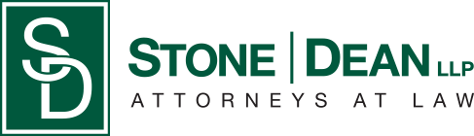
21052 Oxnard Street
Woodland Hills, CA 91367
T (818)999-2232
F (818)999-2269
rhiete@stonedeanlaw.com

Ryan Hiete
Partner

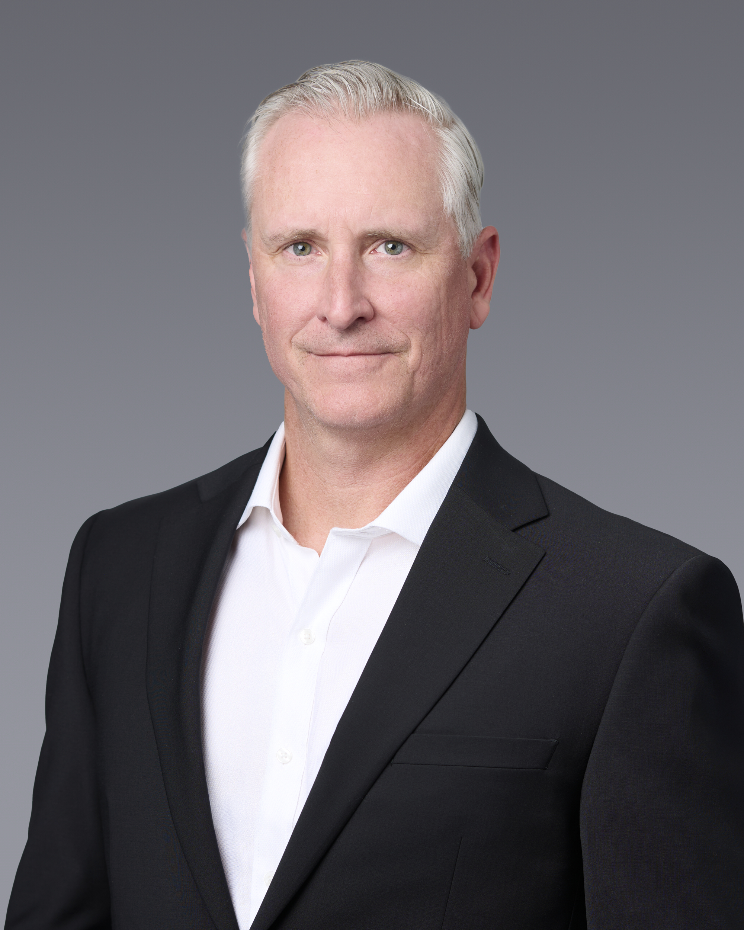

Ryan Hiete, Partner, brings more than 25 years of experience providing strategic counsel on complex environmental, regulatory, compliance, and business litigation matters. Ryan’s practice emphasizes helping clients navigate California’s intricate environmental and land-use regulatory landscape while vigorously defending their interests in civil and criminal proceedings.
Ryan began practicing environmental law in 1999 and has established himself as a trusted advisor to individuals, public agencies, private businesses, manufacturers, developers, and non-profit organizations across Southern California. His work involves regular interaction with federal, state, and local regulatory agencies on a broad spectrum of issues, including groundwater and soil contamination investigations and cleanups, air quality permitting and compliance, zoning and land-use entitlements, CEQA and NEPA reviews and related litigation, Proposition 65 compliance and proceedings, emergency response to chemical and oil spills, environmental due diligence for property transactions and facility sales, hazardous waste and materials management (including RCRA and HSAA), and climate change and greenhouse gas regulatory issues under laws such as AB 32. He also has extensive experience handling government agency investigations and enforcement actions, including OSHA workplace safety investigations, CARB aftermarket auto parts investigations, and U.S. EPA investigations concerning lead and asbestos issues on construction projects.
In addition to his core environmental and regulatory practice, Ryan has substantial experience in business litigation. He represents large corporate clients in defending against complex commercial lawsuits and handles disputes that frequently arise from regulatory compliance, operational challenges, or environmental matters. His litigation background enables him to provide clients with comprehensive, proactive advice that integrates regulatory strategy with risk management and dispute resolution.
Representative Matters:
Ryan has handled a wide array of notable environmental and regulatory projects throughout his career, demonstrating his depth of experience across diverse sectors and issues:
- He has provided ongoing environmental compliance and regulatory counsel to a large public school district, supporting major school construction and modernization programs with CEQA compliance, land-use entitlements, hazardous materials management, and environmental due diligence for new and existing facilities.
- For many years, Ryan has represented the Metal Finishing Association of Southern California (and numerous individual member companies) on a broad range of air quality, hazardous waste, water quality, and permitting issues specific to the metal finishing and surface coating industry. His work includes advocacy before regulatory agencies, compliance program development, and defense in enforcement proceedings.
- He regularly advises industrial and commercial warehouse owners and operators on environmental compliance, stormwater management, hazardous materials handling, due diligence for property acquisitions and leases, and responses to regulatory inspections or enforcement actions.
- Ryan has counseled various public districts, including water districts and airport districts, on environmental permitting, fuel storage and spill prevention compliance, air emissions issues, and remediation of legacy contamination. He has particular experience defending these public agencies in lawsuits involving groundwater contamination claims and alleged violations of the Endangered Species Act.
- His practice includes significant experience in criminal environmental proceedings. He has defended clients in high-stakes matters involving alleged hazardous waste felonies as well as violations of wildlife protection laws, including exotic wildlife cases.
- Among his most prominent emergency response representations, Ryan provided legal counsel to the company that served as the primary first responder to the Cosco Busan tanker oil spill in San Francisco Bay in 2007. He assisted with coordination of the spill response efforts, regulatory interface with federal and state agencies, and related compliance and liability matters.
These matters reflect Ryan’s ability to manage multifaceted environmental challenges—from large-scale public infrastructure projects to industrial compliance programs and high-profile emergency responses—while delivering practical, results-oriented solutions tailored to each client’s needs.
Education:
- McGeorge School of Law, University of the Pacific, Juris Doctor, 1999 (visiting student at Loyola Law School, where he served on the staff of the Loyola Law Review)
- University of Colorado, Boulder, B.A. in Political Science, 1994
Admissions:
- State Bar of California
- United States District Court, Central District of California
Recognitions & Professional Activities:
- Named one of the Top 50 Environmental Attorneys in Los Angeles by the Los Angeles Business Journal (2008)
- Selected as a Rising Star by Super Lawyers (2009, 2012)
- Former member of the Executive Committee, Los Angeles County Bar Association Environmental Section
- Frequent speaker and author on environmental compliance, regulatory strategy, and issues affecting California businesses and public agencies
Ryan remains actively involved in the Ventura County and greater Southern California community. He has coached youth sports for his three children, including basketball, girls softball and tackle and flag football. Ryan has supported many local programs through the YMCA and other non-profit organizations.

