
21052 Oxnard Street
Woodland Hills, CA 91367
T (818)999-2232
F (818)999-2269
mdattaray@stonedeanlaw.com

Mainak D’Attaray
Senior Associate

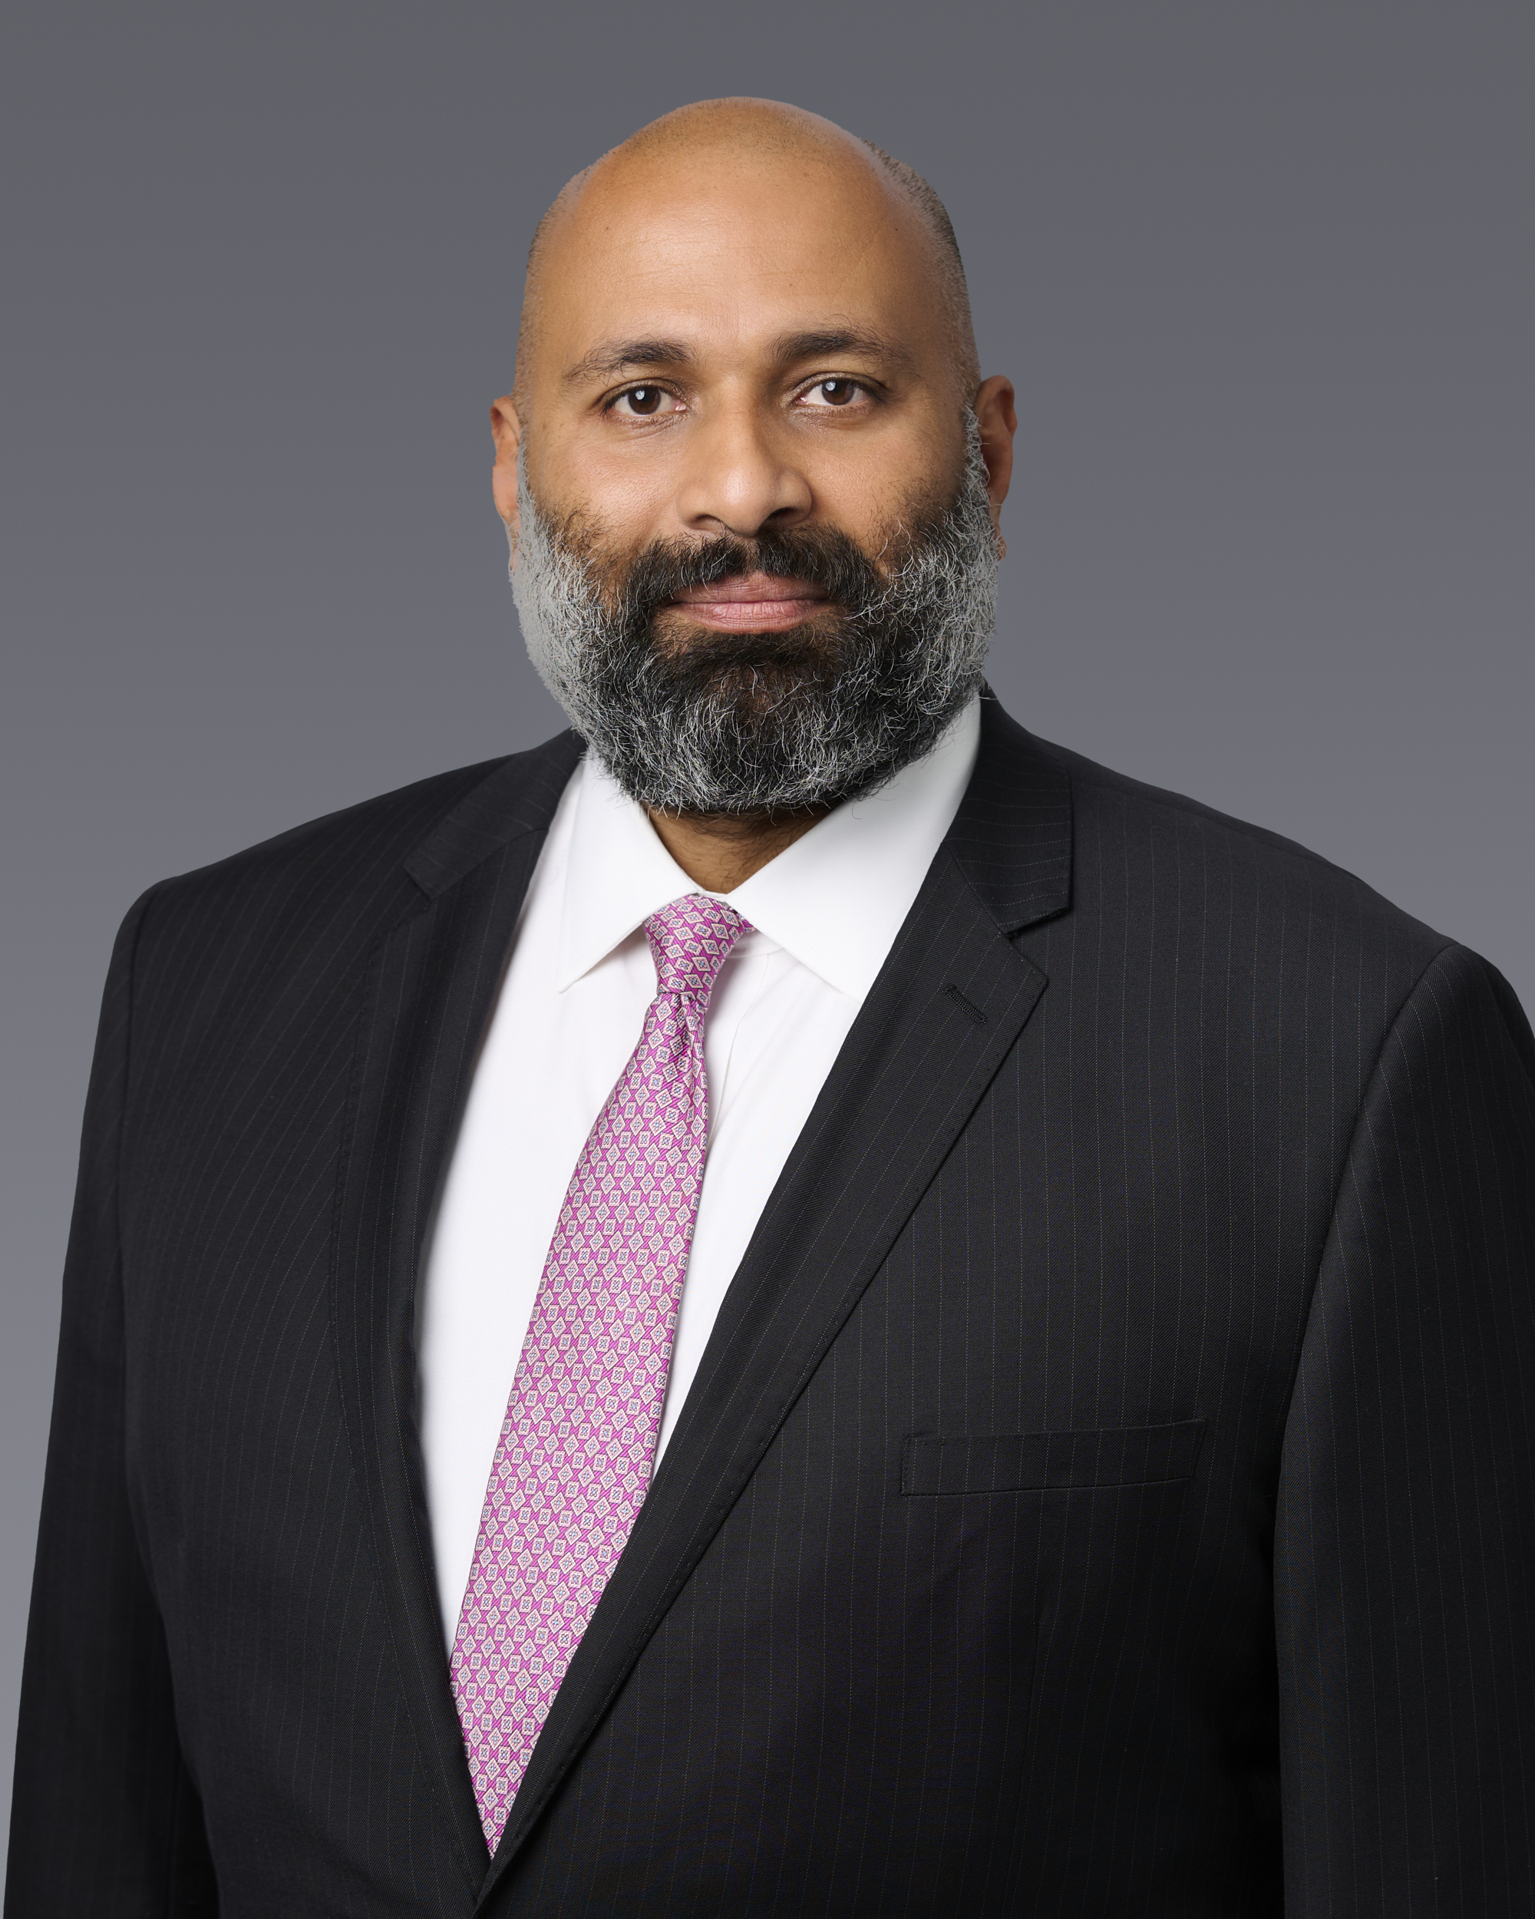

Mainak D’Attaray is a Senior Associate at Stone I Dean with extensive experience in complex civil litigation, including business and real estate disputes, personal injury, employment, habitability, insurance defense, and general commercial litigation. He has represented both plaintiffs and defendants in state and federal courts and brings significant experience managing matters from inception through trial.
Prior to joining Stone I Dean, Mainak was the owner and sole proprietor of the Law Office of Mainak D’Attaray, where he handled business and real estate litigation and transactional matters for business and individual clients. He also served as Senior Litigation Attorney at Farahi Law Firm and held litigation roles at several respected California firms, with experience spanning insurance coverage, premises liability, habitability, employment disputes, unlawful detainers, and complex commercial litigation. Mainak received his law degree from the University of Colorado Law School, where he was awarded a full law tuition scholarship and the Irving P. Andrews Leadership Award. During law school, he earned multiple honors in mock trial and national trial competitions. In his free time, Mainak enjoys spending time with family and friends, traveling, and staying active.
Areas of Practice:
- General Civil Litigation
- Business Litigation
- Real Estate Litigation
- Personal Injury
- Premises Liability
- Habitability
- Insurance Defense and Coverage
- Employment and Labor Litigation
- Commercial Disputes
Education:
- Bachelor of Arts, Philosophy, University of California, Los Angeles
- Juris Doctor, University of Colorado Law School
Membership and Activities:
- State Bar of California
- United States Court of Appeals for the Ninth Circuit
- United States District Court for the Central District of California
- United States District Court for the Southern District of California
- United States District Court for the Northern District of California
- United States District Court for the District of Colorado

