
21052 Oxnard Street
Woodland Hills, CA 91367
T (818)999-2232
F (818)999-2269
asharlakian@stonedeanlaw.com

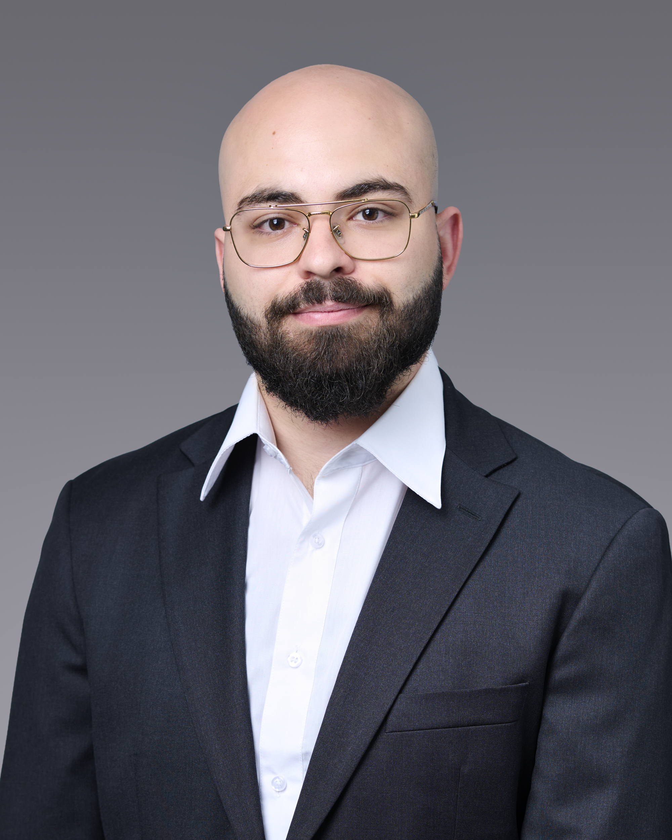
Alexei Sharlakian
Accounting Assistant

Alexei Sharlakian, accounting assistant, supports the firm's financial operations through invoice processing, billing, and accounting. He holds a Bachelor of Science in Finance from California State University, Northridge, and is a CFA candidate. His background in insurance operations and financial reporting brings strong attention to detail and accuracy to the firm's back-end workflows.
Outside of work, Alexei's faith is central to his life. He is an active member of his church and is currently studying Christian apologetics. He also enjoys spending time with his family, training at the gym, and running a small Etsy shop.

