
21052 Oxnard Street
Woodland Hills, CA 91367
T (818)999-2232
F (818)999-2269
aarutyunyan@stonedeanlaw.com

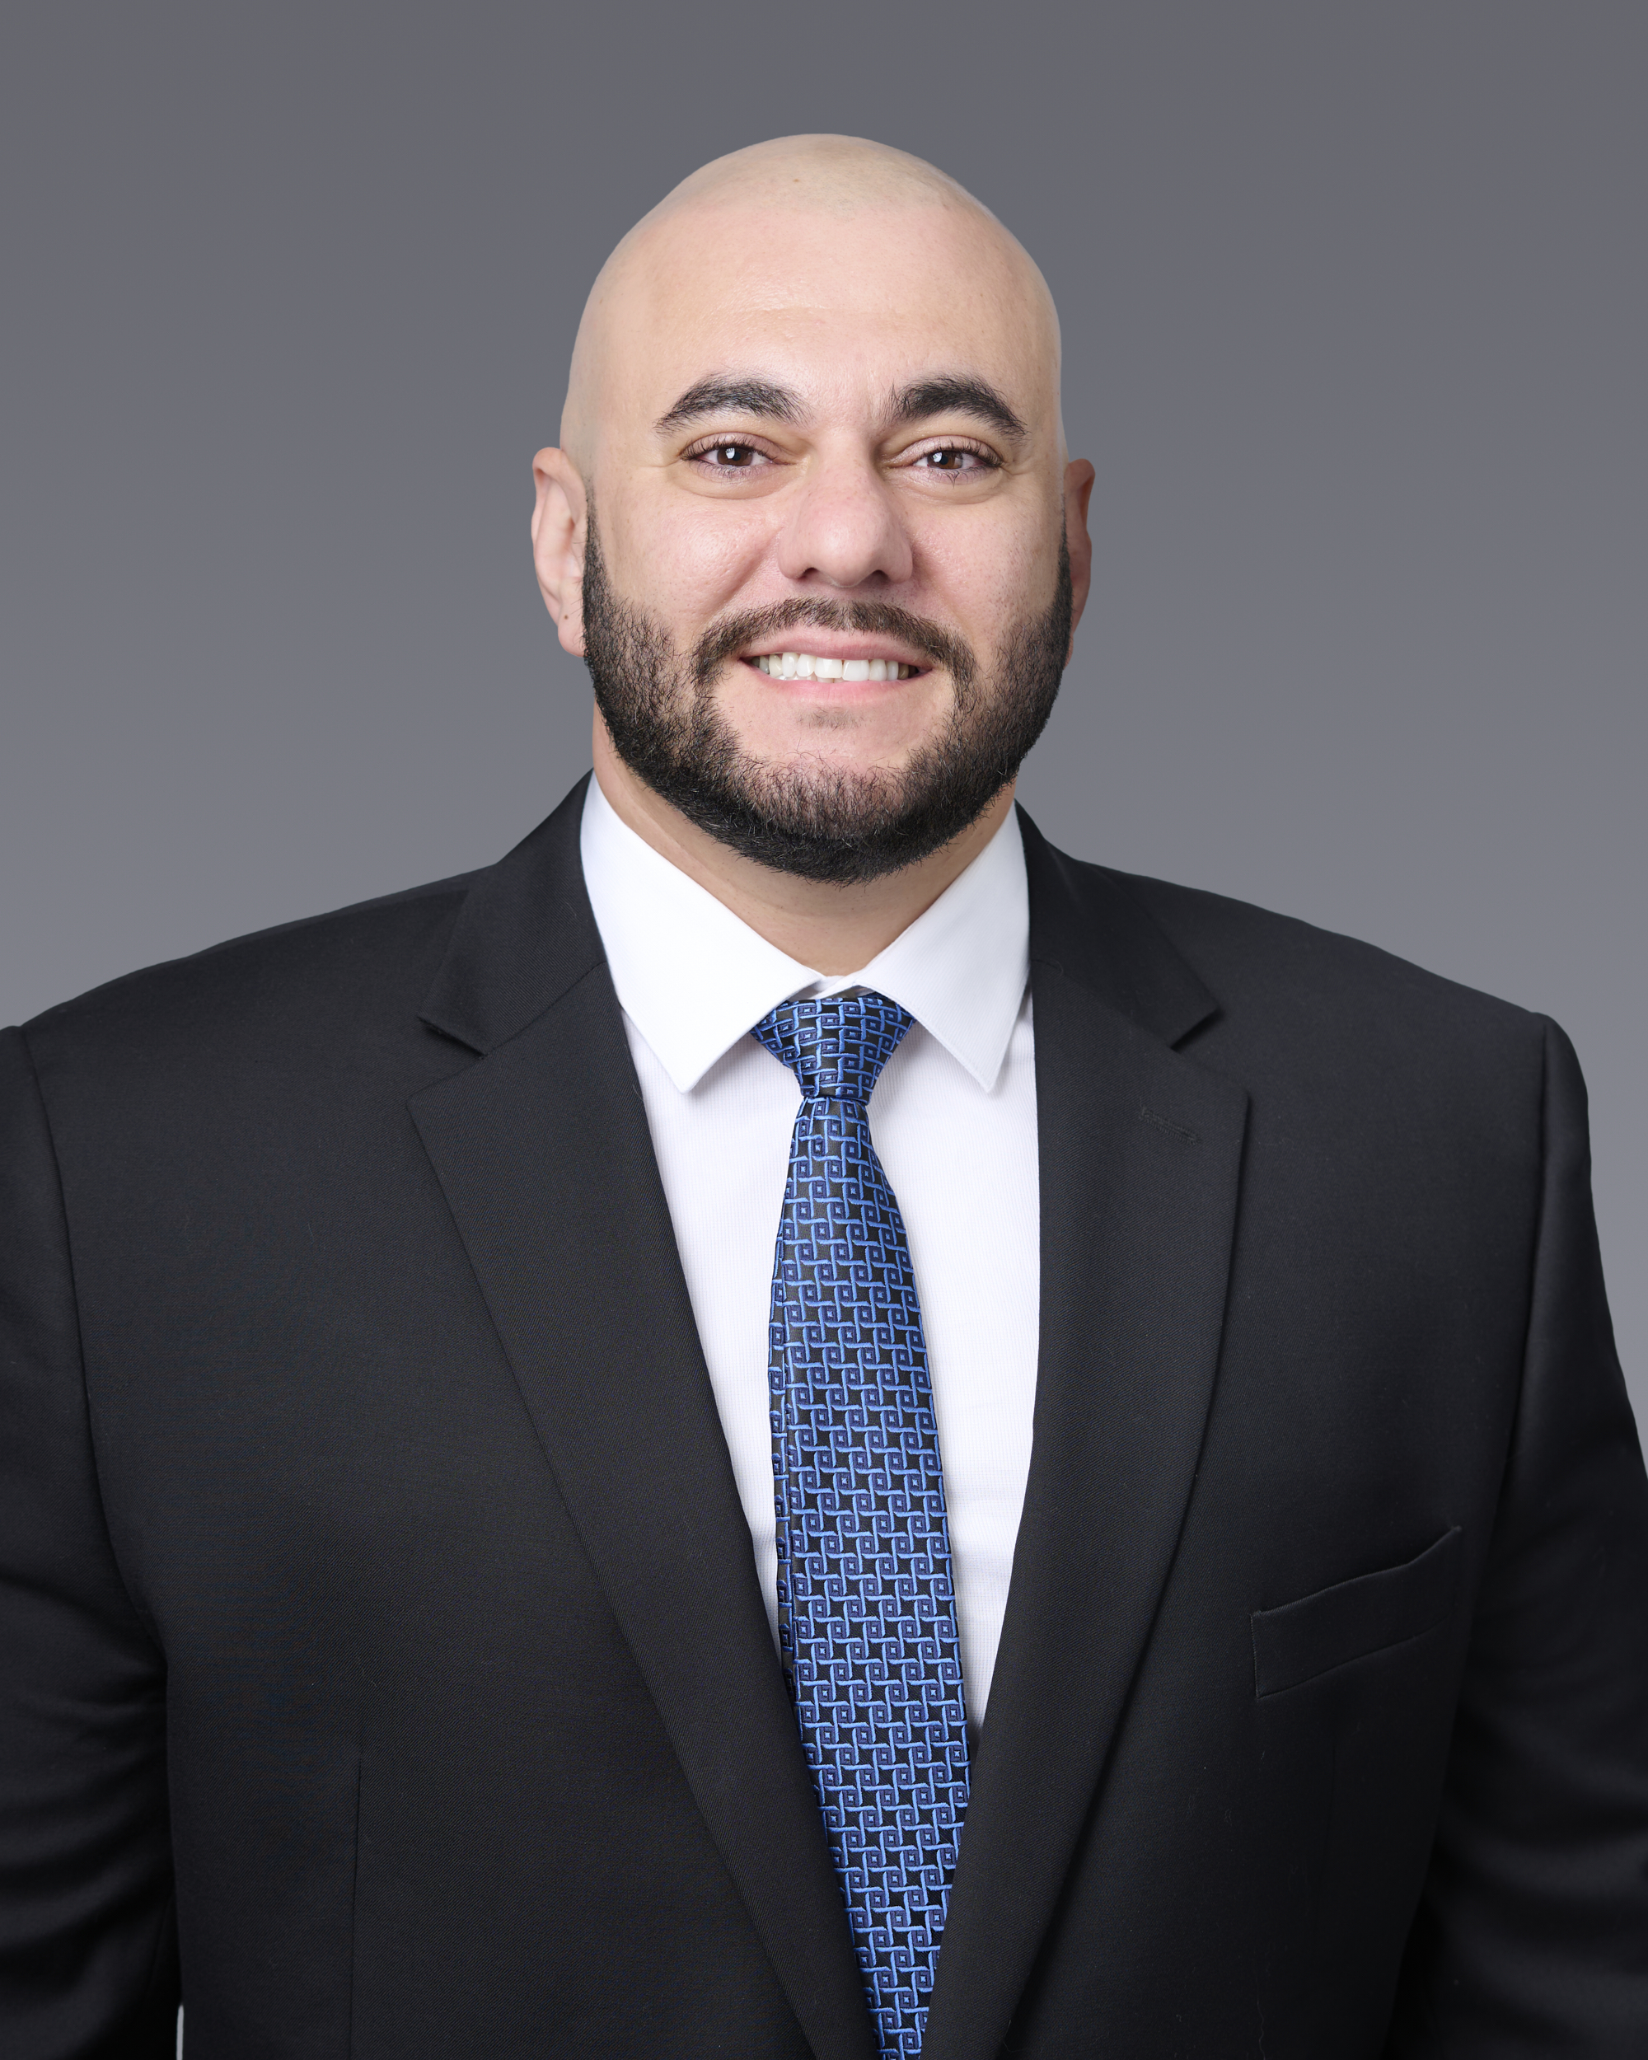
Arman Arutyunyan
Paralegal

Arman Arutyunyan, paralegal, brings five years of specialized experience in personal injury law to the team. A graduate of the University of La Verne College of Law, he earned his Juris Doctor (JD) with a commitment to legal excellence and advocacy.
Outside of the office, he is a firm believer in staying active and giving back to the community. He is an avid weightlifter and a devoted animal lover; when not at the gym, he spends time volunteering at the local animal shelter to support animal welfare.

