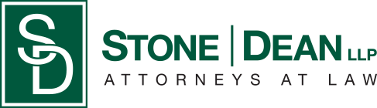
21052 Oxnard Street
Woodland Hills, CA 91367
T (818)999-2232
F (818)999-2269
ntoliver@stonedeanlaw.com


Nakita Toliver
Legal Assistant

Nakita Toliver, legal assistant, possesses over 20 years of experience working in law firms on both the east and west coasts, serving in a hybrid role as a legal secretary and paralegal. She is highly skilled in case management, organization, and litigation filings, and effectively oversees the daily operations of our expanding law firm.
In her personal time, Nakita enjoys spending time with her son, Darin, and her cat, Gigi. She is also committed to community service, regularly volunteering on Skid Row and engaging in community activism.

