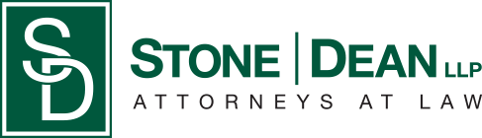
21052 Oxnard Street
Woodland Hills, CA 91367
T (818)999-2232
F (818)999-2269
rhester@stonedeanlaw.com

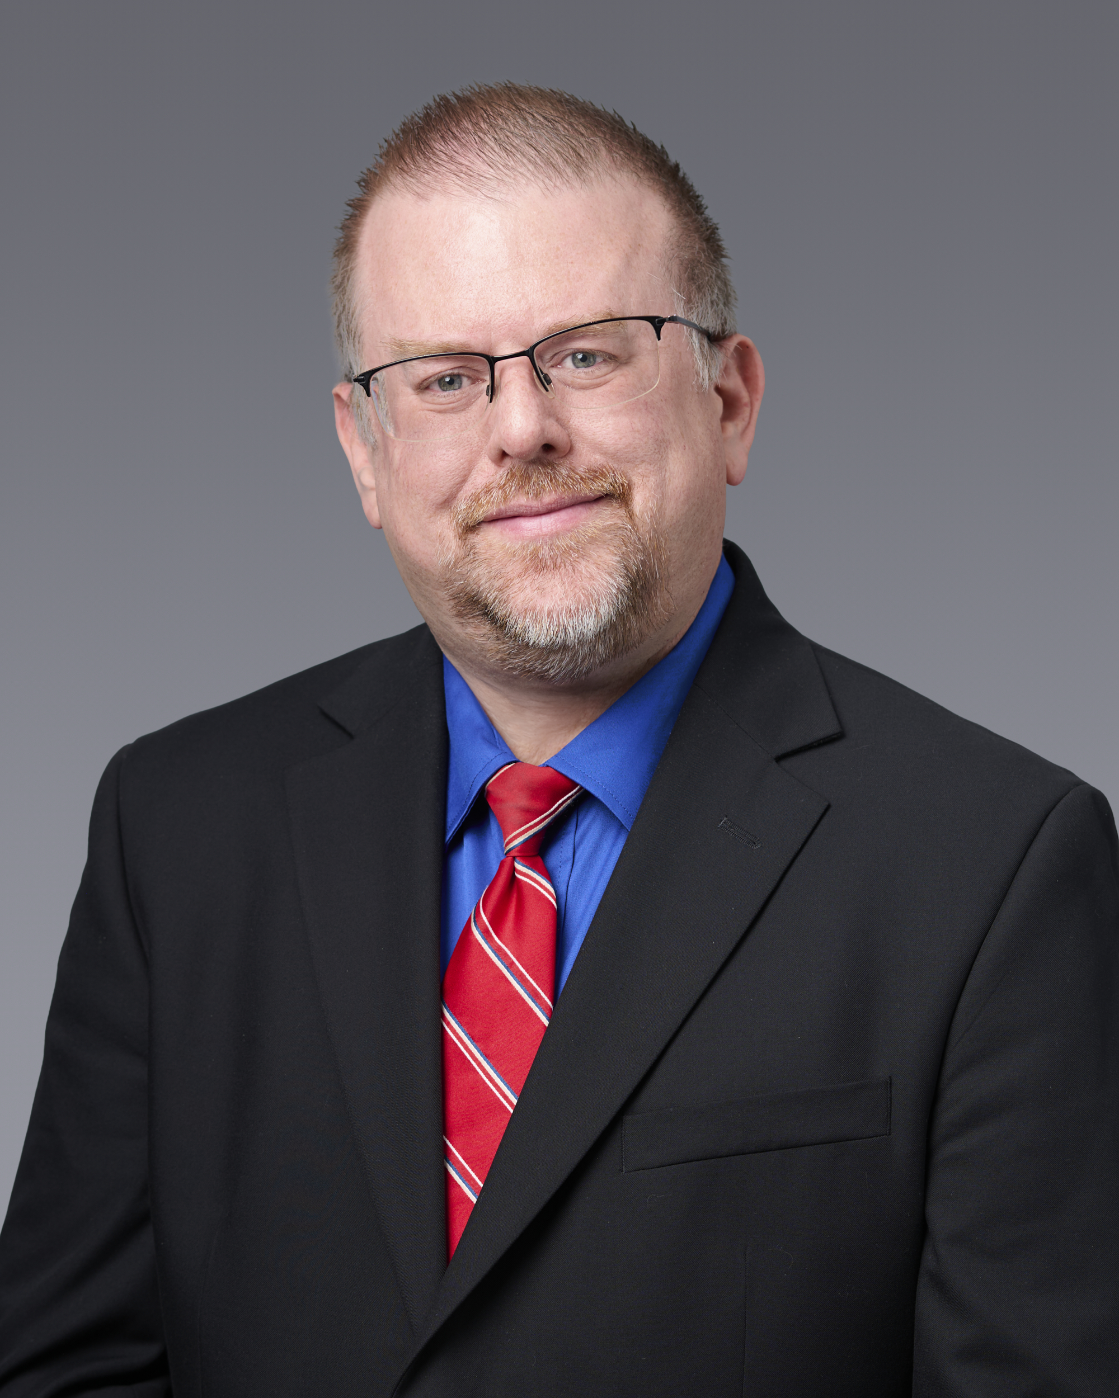
Robert Hester
Paralegal

Robert Hester, Paralegal, has over 27 years of diverse and varied paralegal experience in highly deadline driven environments requiring an extremely high level of accuracy and attention to detail. He is keenly adept at managing multiple tasks with changing requirements and deadlines. He has a commitment to supporting attorneys and clients with professionalism. He holds a Bachelor of Arts in Law & Society from UCSB and a Paralegal Certificate from an ABA-approved program. Robert Hester is an active member of the Ventura County Paralegal Association, where he continues to expand his legal knowledge and engage with other professionals in the field.
Outside of work, he enjoys cooking, bowling, hiking, traveling, and attending sports events and concerts.

