
21052 Oxnard Street
Woodland Hills, CA 91367
T (818)999-2232
F (818)999-2269
tbentovim@stonedeanlaw.com

Tallie Bentovim
Associate Attorney

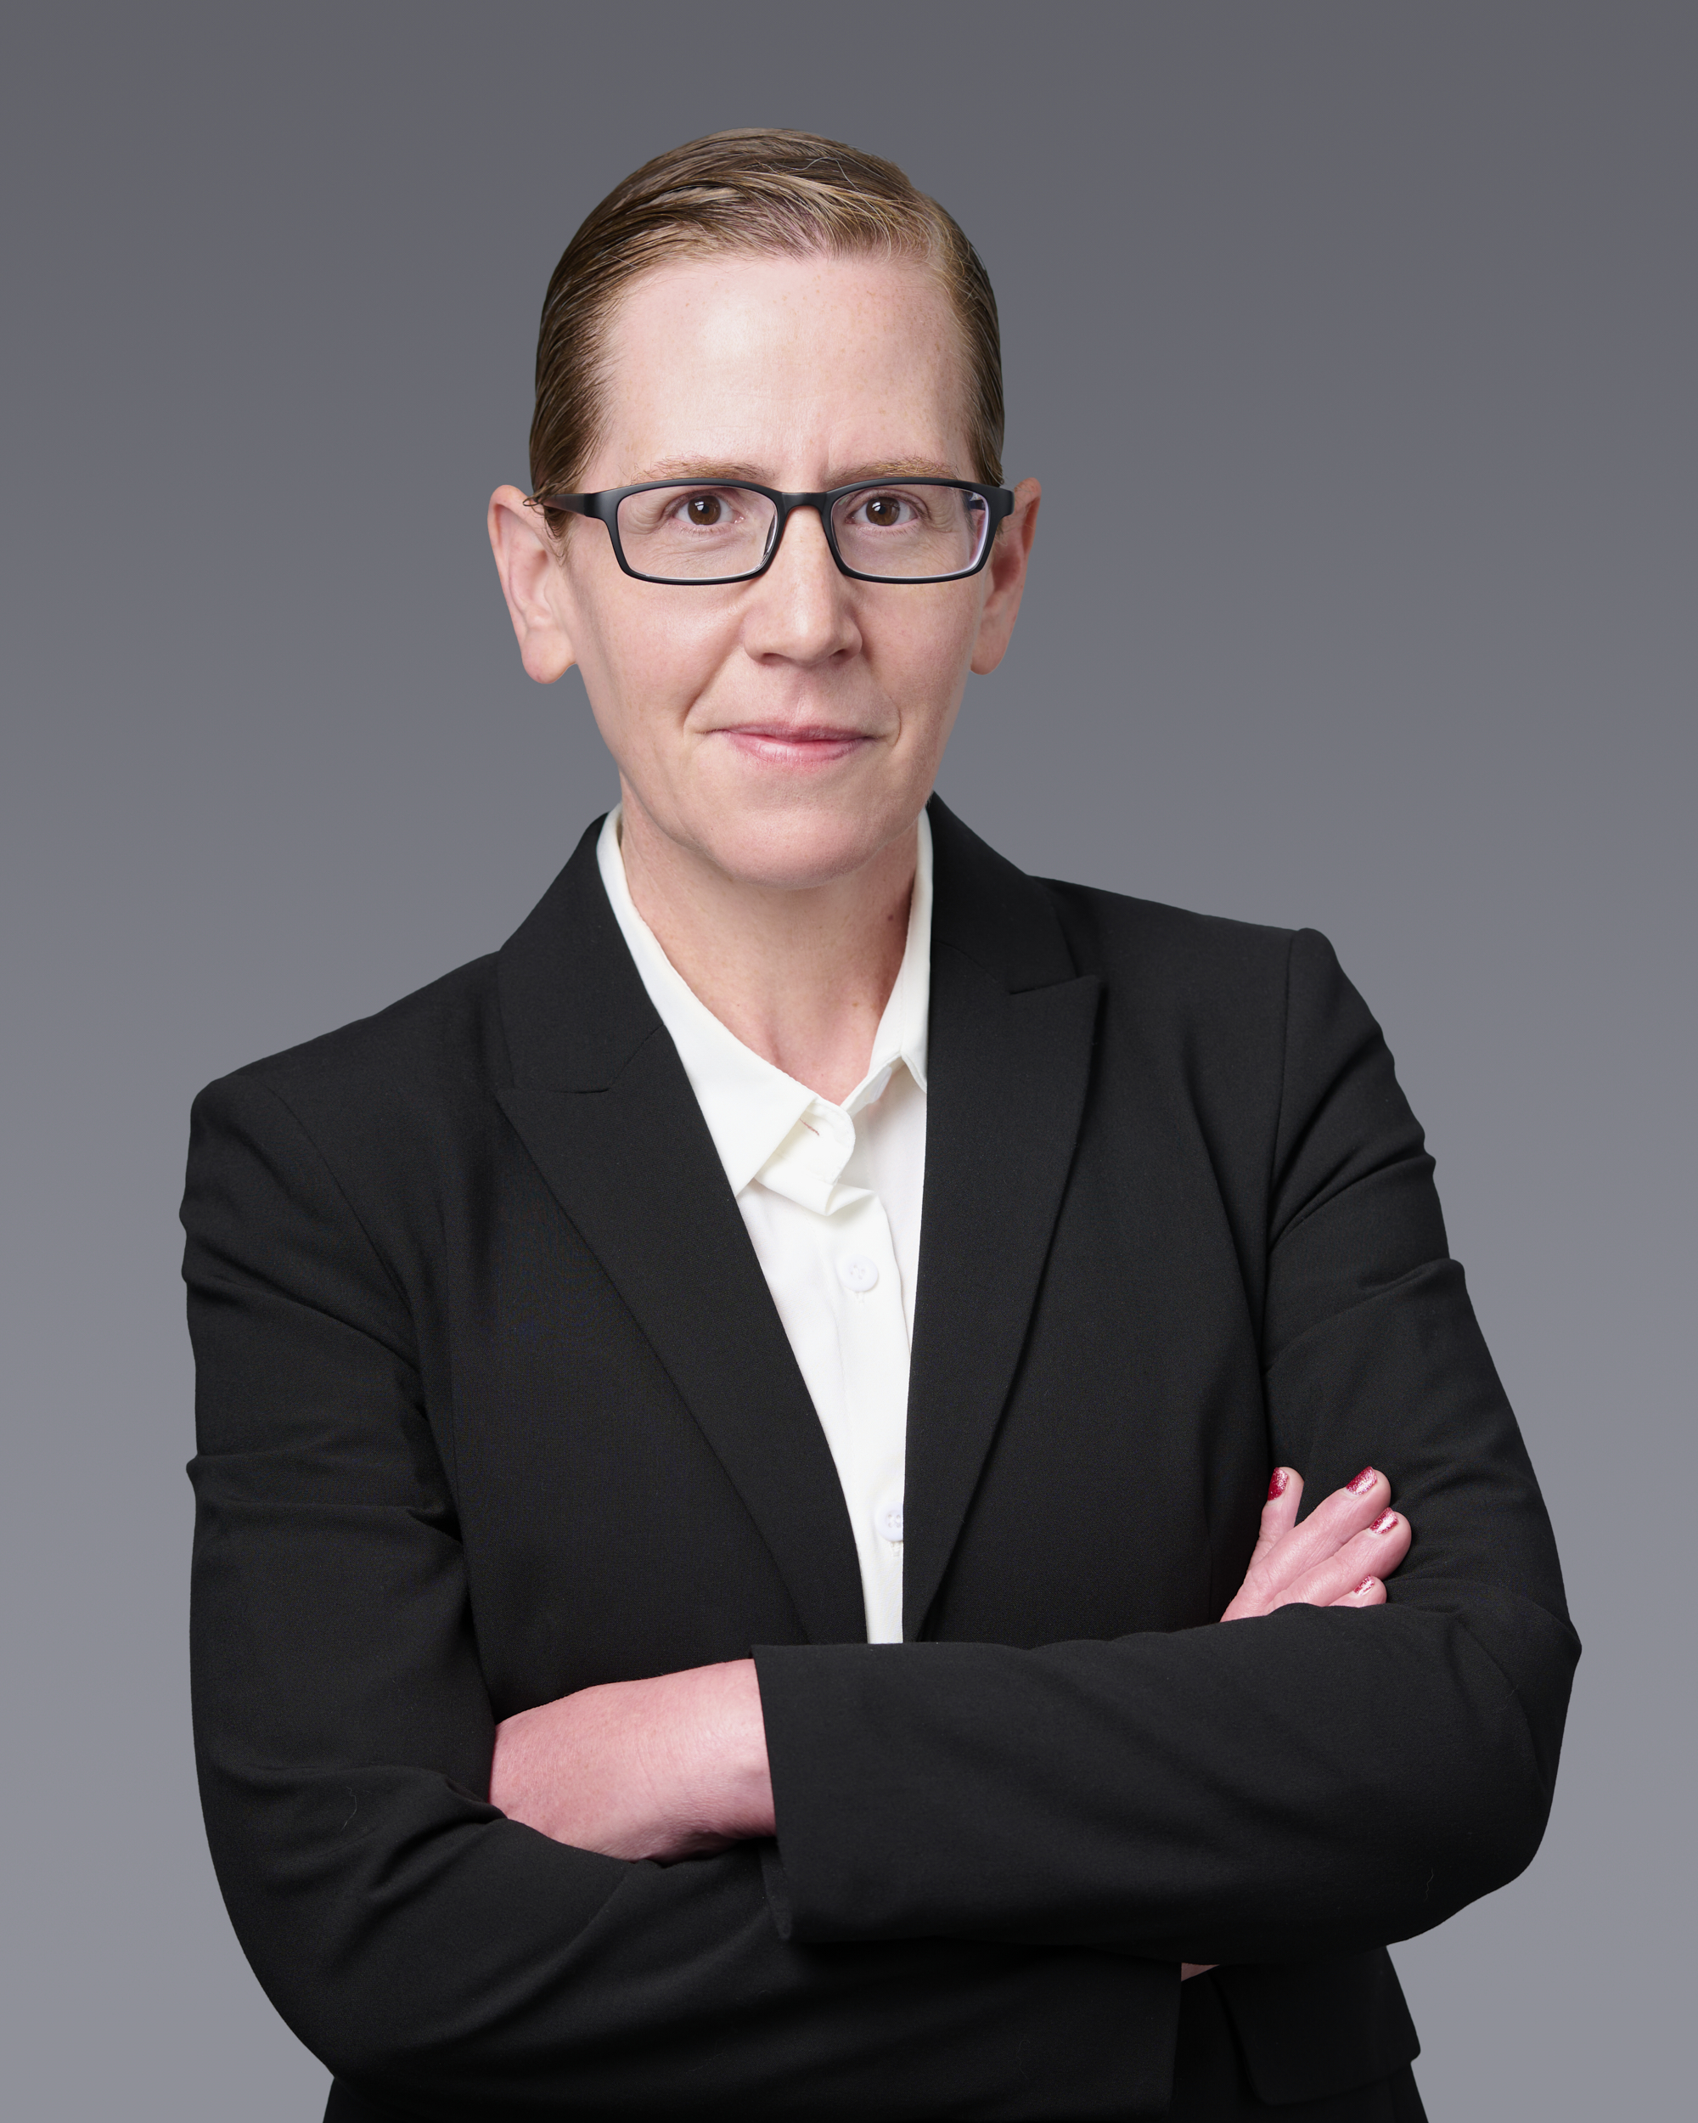

Tallie Bentovim, associate attorney, focuses her practice on personal injury, premises liability, and insurance-related disputes. She has extensive experience defending high-exposure cases through all phases of litigation, including case assessment, discovery, alternative dispute resolutions, motion practice, bench, and jury trials.
Tallie brings more than two decades of international legal experience to her practice. Her legal career began in Israel where she focused on employment litigation and administrative/human rights petitions to the supreme court of Israel. She later relocated to the United Kingdom, where she worked in the property litigation department at Dechert LLP and at Littleton Chambers alongside renowned barrister Clive Freedman on complex, high-profile fraud, negligence, and defamation matters. Her diverse experience across multiple jurisdictions and litigation disciplines provides her with a broad strategic perspective and strong analytical skills.
Areas of Practice:
- General Civil Litigation
- Insurance Defense
- Personal Injury Defense
- Premises Liability
Education:
- LLB from the Hebrew University of Jerusalem
Membership and Activities:
- State Bar of California
- Israeli Bar Association
- The Law Society of England and Wales
Additional Languages:
- Hebrew

