
21052 Oxnard Street
Woodland Hills, CA 91367
T (818)999-2232
F (818)999-2269
cchittenden@stonedeanlaw.com

Cathy Chittenden
Senior Associate

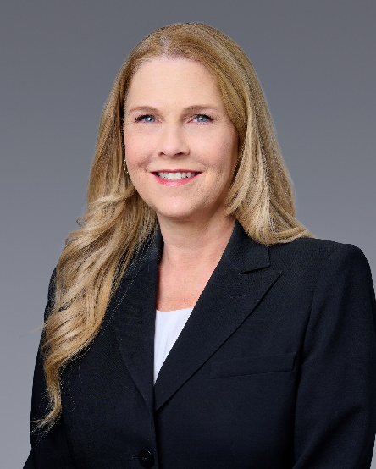

Cathy A. Chittenden, Senior Associate, has been practicing law in business and insurance related areas since 2021. She also has experience in employment defense, medical malpractice defense, toxic tort defense, copyright infringement and contract disputes. Prior to obtaining her JD she worked as a paralegal for ten years assisting in all areas of law practice. As a litigator, Ms. Chittenden has participated in both State and Federal trials as a second chair. These trials ranged from Personal injury to misappropriation of trade secrets.
Areas of Practice:
- Commercial Litigation
- Insurance Defense (commercial)
- Employment Litigation
Education:
- Bachelor of Science, Business Administration, California State University Fresno
- Juris Doctorate, Thomas Jefferson School of Law, San Diego
Membership and Activities:
- State Bar of California
- United States District Court for the Central District of California
Personal:
- Ms. Chittenden enjoys travel, exploring new restaurants in the Los Angeles area, going to movies and spending time with her adult daughter. She also enjoys painting and trying to be creative.

