
James Wilia
Legal Assistant
21052 Oxnard Street
Woodland Hills, CA 91367
T (818)999-2232
F (818)999-2269
jwilia@stonedeanlaw.com

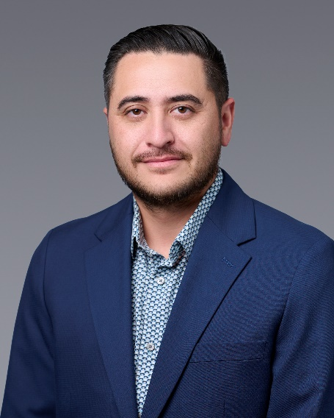

James Wilia, Legal Assistant, is also a Certified Paralegal with more than six years of experience in civil litigation and insurance defense. He earned his bachelor’s degree in finance, with an emphasis in Financial Analysis, from California State University, Northridge, bringing a strong financial foundation to his legal work. He works closely with both partner and associate attorneys, providing support on a wide range of litigation matters, including motor vehicle accidents, personal injury claims, slip-and-fall cases, and other complex civil disputes.
Outside of the office, James enjoys camping, running, and spending quality time with his family and friends.

