
21052 Oxnard Street
Woodland Hills, CA 91367
T (818)999-2232
F (818)999-2269
siezza@stonedeanlaw.com

Sofia Iezza
Law Clerk

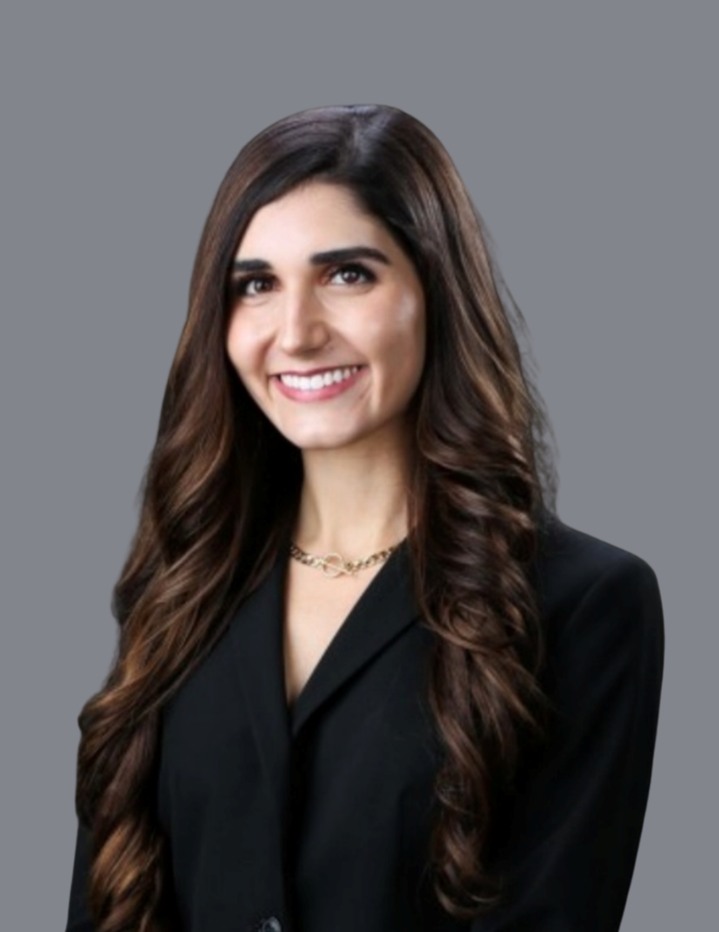

Sofia Iezza, Law Clerk, is entering her second year of law school in the Juris Doctor program at Pepperdine Caruso School of Law. Her goal is to become a litigation attorney after graduation. At Pepperdine, she is the Vice President of the Intellectual Property Student Organization, a Palmer Fellow at the Palmer Center for Entrepreneurship and the Law, and a member of the Catholic Law Students Organization. She holds a Bachelor of Science degree in Science-Business from the University of Notre Dame (2022) and a Master of Cosmetic Science degree from the University of Cincinnati (2025). Before law school, she worked as a research and development chemist in the cosmetic industry, formulating a wide range of products for household name brands. During that time, she developed strong interests in intellectual property law, business litigation, and regulatory and compliance matters. She enjoys translating her research and analytical skills from her technical background into the legal field.
As a law clerk, Sofia assists the firm’s attorneys with drafting and reviewing documents, conducting legal research, and trial preparation.
Outside of work and school, Sofia enjoys spending time with her family, traveling, and listening to Italian music.

