
21052 Oxnard Street
Woodland Hills, CA 91367
T (818)999-2232
F (818)999-2269
cdavis@stonedeanlaw.com

Calvin Davis
Associate Attorney

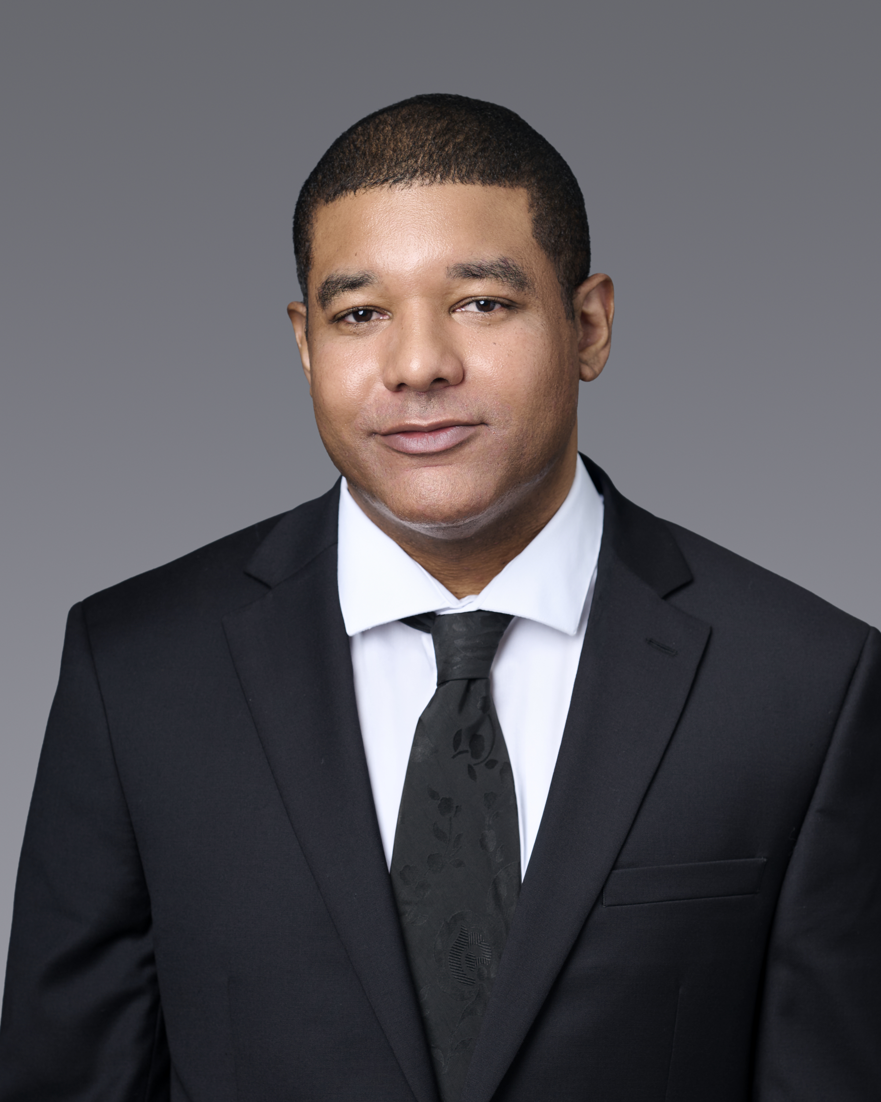

Calvin Davis, Associate Attorney, has represented clients, both plaintiffs and defendants, throughout the state of California and nationally for over 10 years. His range of experience covers personal injury, premises liability, defense of banks, creditors and collection agencies, tenant’s rights, employment and the California lemon law. Mr. Davis is admitted to practice before all California state courts as well as the United States District Court – Central, Southern, Eastern and Northern Districts of California.
Mr. Davis received his Juris Doctor from Loyola Law School, Los Angeles and a Bachelors in Business Administration from Howard University, Washington, D.C. While in law school, Mr. Davis was a judicial extern at the U.S. Bankruptcy Court: Central District of California for Hon. Judge Alan M. Ahart. Mr. Davis also volunteered with Loyola Law School’s bankruptcy clinic at the Legal Aid Foundation of Los Angeles.
Outside of practicing law, Mr. Davis enjoys sporting events, weight lifting and movies.

